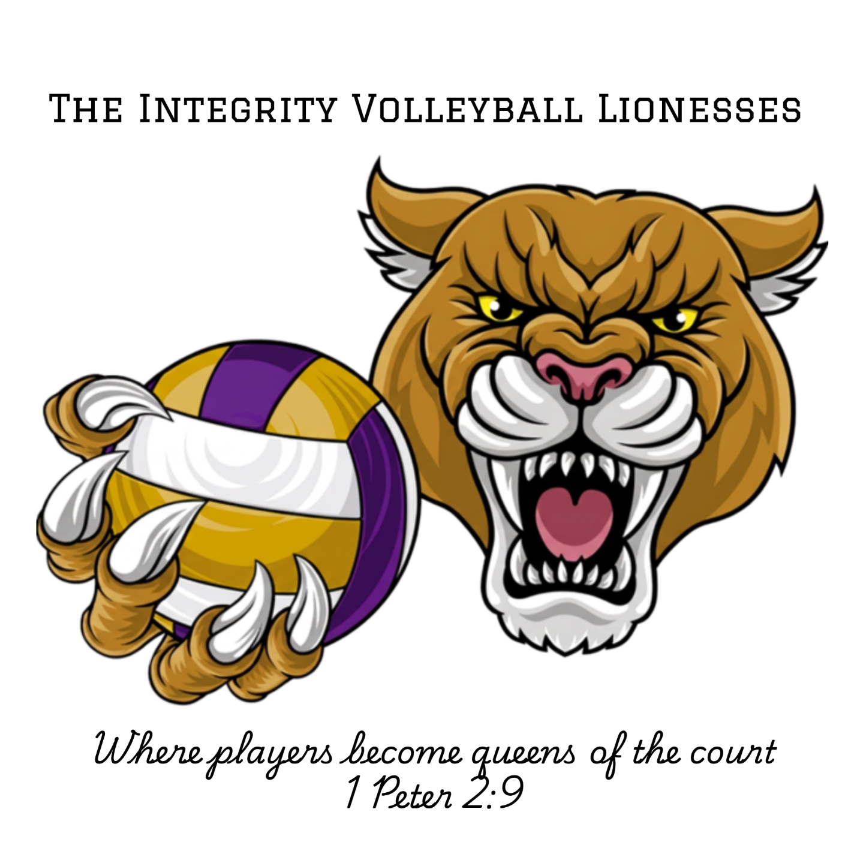
“But you are a chosen people, a royal priesthood, a holy nation, God’s special possession, that you may declare the praises of him who called you out of darkness into his wonderful light.”
2026

Integrity Varsity Volleyball Expectations 2026

Student Athlete:
- Come to practices, matches, & tournaments with a GROWTH MINDSET. You are learning volleyball, even if you have played before. It’s ok to make mistakes you are learning! I just ask that you choose to be teachable.
- Be an encourager. I hope to instill the value of being a team. That means having each other’s backs on the court and outside the gym. Cheer each other on. Support those that are struggling. If you are talking about a teammate or coach at school, on the phone, social media, in the gym, on the bench, etc. I expect it to be positive. This truly makes a difference for a team. If there is an issue, have a conversation to try to remedy the situation with the coach/athlete. Queens don’t lower themselves to gossip or badmouthing others.
- Come to practice and games on time and ready to go, knee pads on, water bottles filled, hair pulled back, etc.
- Cell Phones: Cell phones MUST stay put away during practices and matches. I ask you pay attention to your duties like line judging, scorekeeping, cheering on the team. Please do not get on your phone when you are getting a drink or sitting on the bench. You may use them before practice or after practice.
- Communicate: Please communicate with Coach Kim (419-308-1464) if you are going to miss a practice, match, tournament, etc. It is very important to keep our team up to speed on positions, planning practices, etc.
- Remember I am here for you. This feeds off communicating with me. If you have something going on outside of volleyball, we can set up a time before or after practice for you to meet with me if you need it. I truly care about my athletes and their families and want the season to be positive for everyone.
- Please have the entire team stay until our whole team is done with the match/tournament/cleanup. If you aren’t playing on the court or serving as a line judge, ref, scorekeeper, etc.- it is a great time to learn from watching other teams play.
- Respect one another, the other teams, coaches, refs, fans, & facilities.
- All the music in the gym, or when participating in any IVB activities, etc. is clean. If you need help finding clean music, ask Coach Kintner for assistance. (*Coach Kintner will be using a playlist of her own with Christian music in the gym*)
- Show up with class. We treat others and their property with respect.
- If you would like to discuss playing time, do not have your parents ask me- the athlete should approach me as a coach directly. I can always give you suggestions on skills to improve on, etc. That does not guarantee play time but helps to guide you on how to get more playing time.
- Keep your grades up.
- Social media expectations- your social media posts should reflect the Integrity Volleyball Team. Wherever you go, you are a walking billboard for our brand. Again, keep it classy. We do not tolerate racism, inappropriate posts, bullying, harassment, etc. This is qualification to be released from the team.
- Follow and abide by typical student athlete rules (no drugs, drinking, fighting, etc. These are causes for dismissal from the team).
- Queens don’t complain about the tough work that needs to be done. When it’s time to work on skills, drills, speed and agility, or strength training, we train. There is a time for fun & games but this is a competitive team and we want to learn how to properly play volleyball.
- Playing time is NEVER guaranteed. Please enter this season with a “We” mindset instead of a “Me” mindset. Coach Kintner will do her best to get everyone playing time. On that note, some things that will affect a players playing time (this is not an exclusive list):
A. Safety: Obviously, if I feel your athlete needs pulled off the court for any reason for their safety, I will do so.
B. Attitude: This is HUGE! If I see disrespect towards another player, the other team, a ref, a parent, or me as the coach, you will be pulled from the court immediately.
C. Missing Practices: Once August starts, all practices, matches and tournaments are mandatory. If you need to miss for things like illness, a pre-planned family vacation, etc. Please let me know as soon as possible. I do excuse these, however, sometimes the athlete still misses something new at practice (like a new rotation or where to be on the court, etc.) I do try not to penalize for excused absences and try to help the athlete get caught up to speed as soon as possible for them. However, if you have unexcused absences from practices/matches/etc. you will lose playing time. It is not fair to the athletes who are showing up to practice and putting in more work to lose playing time to someone that skips. Unexcused absences are for things like: “I decided to go shopping instead of coming to practice.” “I just didn’t feel like going.” “I decided to go get ice cream with my friends instead of coming to practice.” You get the picture. Respect your team and show up for each other.
D. Lack of effort: If you as an athlete are choosing to put in less effort at practice, it could get you less playing time. If it is because you are ill or injured, please let Coach Kintner know. Otherwise, you should be putting effort forth at practices as much as you would in a game.
- Remember that we are a Christian team and want to demonstrate our faith-filled values to love one another.
Remember, your attitude towards me as your coach, the game, drills, and each other will determine how our season goes. Let’s have a great season!
Parents/Guardians:
- Come to games and tournaments with a positive attitude. Please remember that these girls are learning, let’s set the example as adults. If you have any coaching complaints, I ask that you wait 24 hours after a game to message me. Our coaches will not discuss playing time with you but will discuss skills with your athlete that they need to work on.
- Communication is key! I will do my best to communicate with you all as I am gaining information. I ask you also to communicate with me as well. If your child will be missing, or is struggling with something related to volleyball or not, please feel free to reach out to me so I can best help. I know that life happens on and off the court. I do work and coach year-round as well, so if I do not get back to you right away, I will do so as soon as I possibly can.
- Get involved. Every family should sign up for multiple volunteering opportunities. Find ways to encourage the team. Hair ribbons, snacks, team gifts, etc. Often the parents get together and plan some nice things for the girls for tournaments. Please let me know if you need anything from me (roster, names/numbers, etc.) You will need to volunteer for concessions, set-up & tear down at our home matches. We will also need line judge volunteers for matches.
- Help us to find sponsors for our team. Our biggest expense is the gym rental. Please help us to cover our costs through this opportunity! I do not charge this expense to the families as I am trying to keep the cost as low as possible to ensure everyone that wants to play is able to. We appreciate your help on this!
- Thank you for investing in your child! I’m a mother of many and know the time commitment activities like this take. I am thrilled to get to work with such great families with each team I get to coach.
Please don’t hesitate to reach out to me if you have any questions, comments, or concerns. I am so excited to be coaching your child this year and look forward to a fantastic season!
Kim Kintner
Integrity Varsity Volleyball Director & Head Coach
419-308-1464
CoachKimIVB@gmail.com

I agree and will do my best to adhere to the expectations of the Integrity Varsity Volleyball Program:
Athlete’s Name Printed: ____________________________________________________________________________________
Athlete’s Signature:___________________________________________________________________________
Parent/Guardian’s Name Printed:_____________________________________________________________________________
Parent/Guardian’s Signature:___________________________________________________________________________
Date:_______________________________________________________________________________

